Design Methodologies
Waterfall | Requirements (user language)
 | Specification (system language)
 | Implementation / unit testing (checks units against spec)
 | Integration / system testing (checks requirements met)
 | Operations and maintenance
Spiral | Plan (requirements, feedback)
 | Determine objectives / alternatives
 | Evaluate alternative / risks (prototype)
 | Develop / verify (code / test / integrate)
User-Centred | Design a shared conceptual model of the system with the user
 | Anthropology (interview users etc)
 | Collaborate to decide what to solve
 | System mock ups / talk-through
 | CRC (responsibility & collaborators)
JSP | Program structure in terms of data
XP | Pair programming, agile, get feedback from users ASAP
 | Refactor the design when requirements change

UML
Use Case | Describe the human activity that the system has to support
 | Focal point of discussion
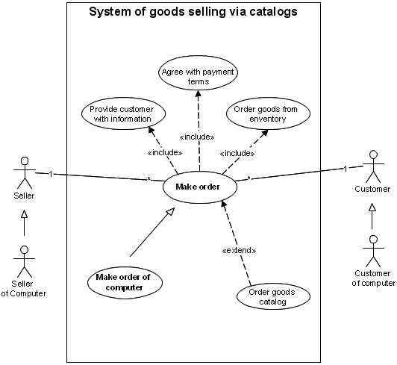
Class | Shows classes & relationships
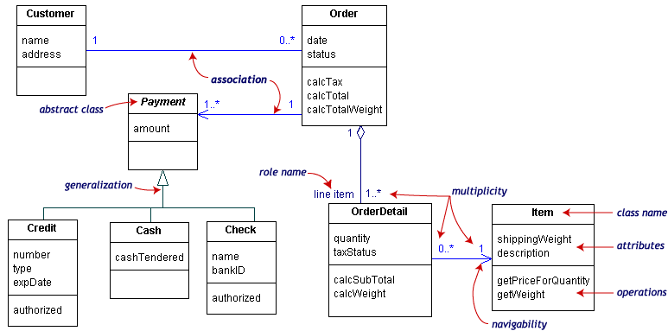
Collaboration | Interaction diagrams focusing on the roles of objects
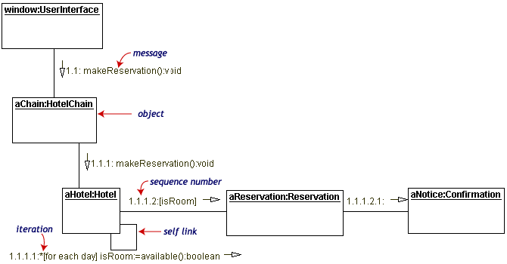
Sequence | Interaction diagrams focusing on the time at which messages are sent between objects
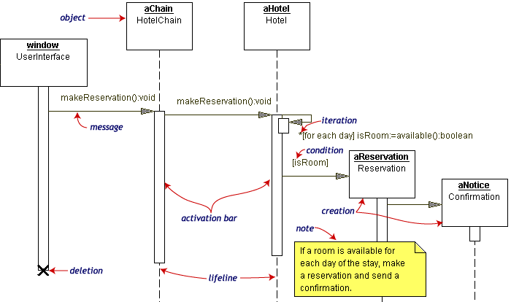
Activity | Shows how object activities are dependent (flowchart)
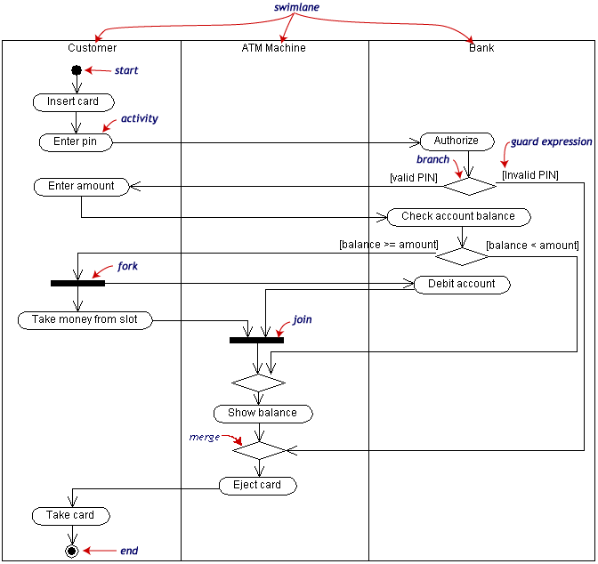
Statechart | Show object lifecycle and internal state transitions
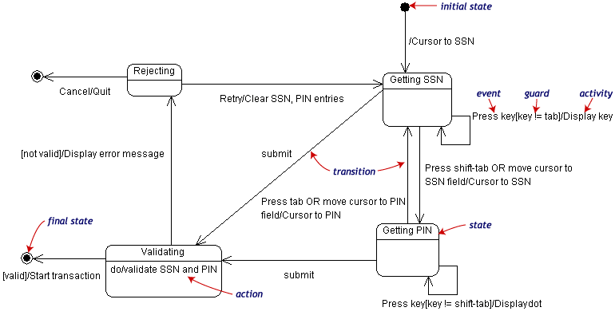
Component | Dependencies between components (could include web pages, EXEs, DLLs etc.)
Deployment | Location of components that make a complete system
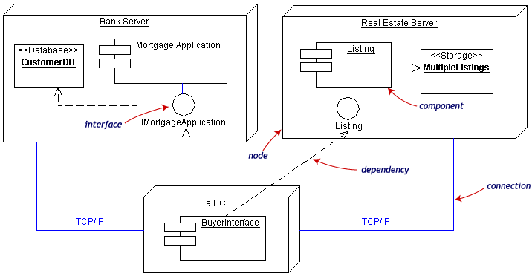

Object Design
Information Hiding | Expose minimum interface
 | No implementation details
Loose Coupling | Minimize object joins
Cohesion | “1 method does 1 thing”
Abstract Types | Hide implementation
 | Interface as specification
Modularization | Separate building / testing
 | Helps code reuse
 | Divide work between teams
 | Change localisation
Method Classification | Mutator and accessor
Responsibility | Classes manipulate own data
Defensiveness | Performance/redundancy tradeoff w/ multiple check
 | How to deal with failure?
 | Exceptions can enforce this
 | Attempt error avoidance

Correctness
Typing | Strong typing can catch errors at compile time
 | Variable “taxonomy”
Formal Models | Define program element
 | If precondition holds then execution means the postcondition holds
 | Composition possible
 | Force fine level analysis
 | Static checking / verification
 | Alternative (declarative) perspective
 | Specialist (Greek letters!)
 | LOD similar to that of code
Patterns | Reusable approaches
Testing | Regressions / unit tests

