Logic Definitions
Literal | Boolean variable
Minterm | Conjunction of all variables complemented or otherwise
DNF | Disjunction of all minterms
Maxterm | Disjunction of all variables complemented or otherwise
CNF | Conjunction of all maxterms
Cover | Term covers a minterm if that minterm is part of the tem
Implicant | A product term T is an implicant of a formula G iif G is true for all input combinations that make T true
Prime Implicant | A product term T is a prime implicant of a formula G iif T is an implicant of G and no proper subterm of T is an implicant of G
Essential Term | A prime implicant which covers a minterm that no other prime implicant covers
Covering Set | A minimum set of prime implicants which includes all essential terms
Static Hazard | Output glitches but returns to the original level
Dynamic Hazard | Output changes state but glitches during the change

Circuits
Fast Carry Adder | $$g_{n}=a_{n}\text{.}b,p_{n}=a_{n}+b$$  $$\begin{aligned}c_{n+1}=g_{n}+p_{n}\text{.}c⇒ \\ c_{n+2}=(g_{n+1}+p_{n+1}\text{.}g_{n})+(p_{n+1}\text{.}p_{n})\text{.}c\end{aligned}$$
RS Latch | 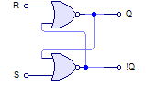
D Latch | 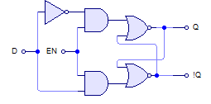
D Flip Flop | 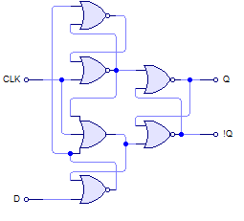  !D  !D When Clock Goes Low  D When Clock Goes Low  !D, Changes To 0 If D Changes When Clock Is Low  -VE Edge Triggered
 | Or alternatively two clocked RS latches in series.
Obscure Sync. Flip Flops
  J | K | Q’
  0 | 0 | Q
  0 | 1 | 0
  1 | 0 | 1
  1 | 1 | !Q
  T | Q’
  0 | Q
  1 | !Q

State Machines
Finite State Machine | Deterministic circuit producing outputs dependent on its internal state and external inputs
States | Set of internal memorized values, shown as circles on diagrams
Inputs | External stimulus to the machine, shown as arcs on diagrams
Outputs | Results from a FSM, associated with a state (Moore) or a function of the state and inputs (Mealy)
Start Up | Reset or self starting
State Encoding | Shift, sequential, sliding, one hot

Building Gates From Transistors
FETs | nMOS: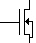 pMOS: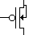
Tristate Buffer | 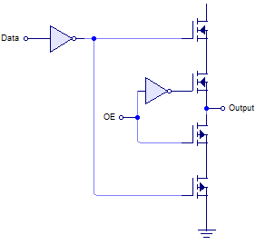

Programmable Logic Devices
ROM | Implements table lookup O(m*2^{n})
PAL | Selectively remove connections in NOT, AND and OR planes, scale with number of terms not states

