Algorithm Construction
Notation | $$f(x)=O(g(x))⇔\underset{x→∞}{\text{lim}}\frac{g(x)}{f(x)}>0$$
 | $$f(x)=Ω(g(x))⇔\underset{x→∞}{\text{lim}}\frac{g(x)}{f(x)}<∞$$
Memory Models | Caches and virtual memory can make memory an issue of speed
Strategies | Divide, conquer, combine
 | Greediness: make the choice which seems best right now: problem must have optimal substructure (solution for one problem is contained within the solution for larger problems)
 | Dynamic programming: used where subproblems overlap (remembers partial solutions by solving increasingly large problems or by memoisation)
ADTs | May model application with successively decomposed ADTs

Sorting
Selection | Iterates once for every list item: on the ith iteration the next smallest item in the unsorted list is moved to its final position
 | Unstable due to exchanges
Bubble | Iterate over adjacent pairs of items, exchanging them if they are out of order: upon every iteration at least 1 element is moved to its final position
 | Stable
Insertion | Iterates over all list items, and the ith iteration places the ith item in its correct position amongst the first i items
 | This sorting method is stable if you don’t sink on equal key values
Shell | Performs a series of “stride s” insertion sorts on list subsets (subset k (0 ≤ k < s) contains items k, s + k, 2s + k, ..)
 | Try stride sequence s_{i-1} = 3s_{i} + 1
 | Unstable due to subsetting
Quick | Divide items into two partitions by pivot value, recursively quick sort the two halves and finally join everything together
 | Partition by keeping two pointers: one for an item in the left half greater than the pivot, one for an item in the right half less than the pivot. When you have a pair of valid pointers, swap and iterate until they cross, move in partition
 | Can use logarithmic space if you first recurse on the smaller partition then iterate on the larger
 | In-place partition usually unstable
Heap | Create a max-heap by bottom up heapification, then read items off it to the same array in place
 | Unstable
Merge | Mergesort the two halves of the array and then combine the two sorted halves
 | Merge in place by either copying the merged arrays back into the original array or only copy the left sub array to workspace (we will never overwrite the right array before they have been consumed)
 | Stable if we favour first half
Counting | Assume all keys are in range 0 to k – 1, then use items as indexes into an array of that size, incrementing it as a count. When all items are accounted for, translate the counts into indexes into the array that indicate where the last value of that key is to be stored. You can now make a pass backwards through the original array placing each item at the position indicated by the count array, and update the index that array stores appropriately
 | Stable, due to reversed last pass
Radix | A sequence of stable sub-sorts: sort by the digits of the key from least to most significant using e.g. counting sort
 | Stable due to LS digit first
Bucket | If we know that key values are distributed over some range, divide that range into N intervals (buckets), which store linked lists. You can now add items to those linked lists (maintaining sorted order), and do a final pass to read them back out of the buckets

Order Statistics
Quick | Pick an item in the list as a pivot, partition on it then recurse on the appropriate partition
Worst Case Linear | Find the median element of an array storing the medians of each group of 5 elements in the array: this can be used as the pivot
 | Since this guarantees at least 3N/10 values greater than or less than the pivot we get a linear worst case after the partitioning

Data Structures
SLL | Use a sentinel head node to avoid having to special case insertion
Deque | Superset of queue and stack
Heap | Represented as a complete binary tree (every level filled): every node obeys the heap property
 | When stored in an array the node at index i has children at 2i + 1 and 2i + 2
 | Add new items at the end of the array then bubble the new item up by comparing with parent
 | Remove items by moving the last element in the array into the hole then bubbling it down
 | Bottom up heapification works by heapifying on successive subtrees from the lowest levels upwards
Trees | 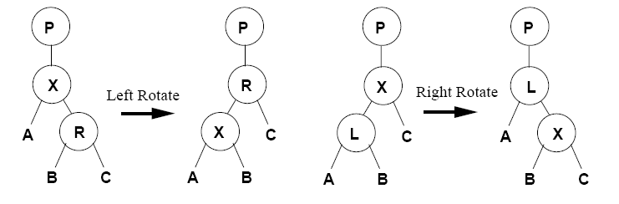
 | Deleting from a BST when there are two non-empty subtrees can be done by moving the smallest node in the right subtree to root and attach the deleted nodes left subtree to it (it can’t have one of its own since it’s the smallest)
Splay Tree | 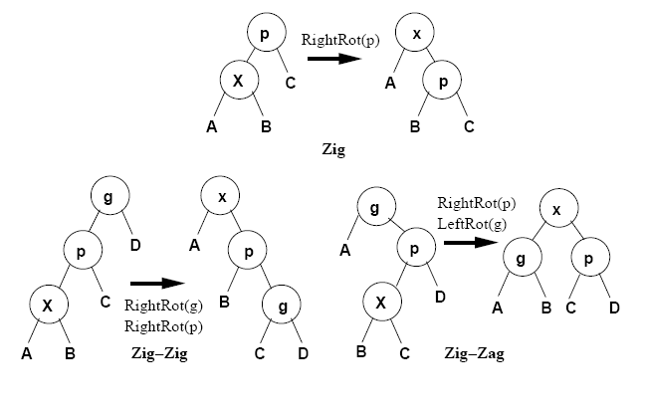
 | Splay nodes (move them to root) as above upon insertion/search
 | Number of comparisons required for M insert/searches in a N node tree is O((N+M)log(N+M)), so for M = O(N) have amortised O(log(N)) amortized cost
 | Cost of any sequence of splay operations is within a constant factor of access to any static tree
 | Adapt to NU access patterns
2-3-4 Tree | All pointers to empty subtrees are the same distance from the root
 | To insert, search until we reach a leaf node. Insertion is now trivial unless it’s a 4-node: in this case split it into 2 2-nodes (inserting the median value from the 4-node into the parent). This may cause cascading inserts: in the case that it reaches the root, split it and increase the length of both sides
 | Avoid cascading inserts by splitting any 4-nodes on the way down the tree
 | To delete, find the node with value to delete. If it is a leaf node, remove it, otherwise find the largest key in its subtree and use it as a replacement. Empty leaf nodes are solved by transferring a key via the parent from a sibling 4-node or by merging a sibling 2 or 3-node with it and taking a key from the parent. This may cause cascading deletions: in the case that it reaches the root, merge the two children of the root and decrease path length
Red-Black Tree | 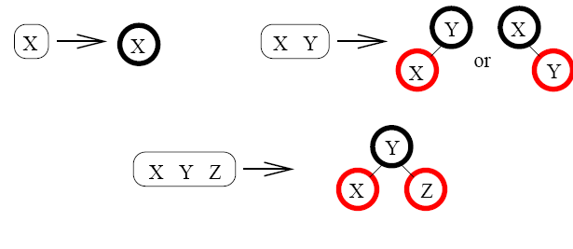
 | Every red node has a black parent, and there must be an equal number of black nodes on every path from the root to a node with fewer than two children (no greater than a factor of 2 out)
 | All operations inferable from the 2-3-4 equivalent to the tree
Skip Lists | A linked lists with various heights of nodes that allow you to skip most items when searching
 | 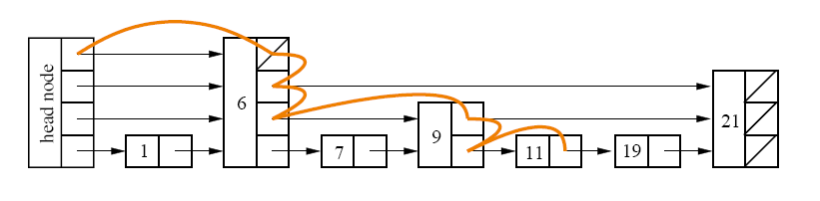
 | Head node acts as a sentinel with the maximum possible height
 | When inserting or deleting, use a helper function which finds the largest node at each level with key less than an argument: this makes the actual operation trivial
 | Given a number of levels O(log(N)) and random distributions at each level have search time O(log(N))
 | Grow the maximum height dynamically: add a level whenever N = 2^{h+2}
 | Choose a nodes height by taking advantage of the fact that it requires Pr(h=k)=2^{-k} and noting that that is the probability of the first k bits or a r.v. being all 0
Hash Table | Use a key value with hash function to index into a hash table
 | Possible hash functions, M table:
 | Divide: h(k) = k mod M
 | Multiply: h(k) = flr[M(kA mod 1)]
 | Open addressing uses secondary probes to find a new bucket given collision, using a hash function h(k, i) where i is probe number
 | Linear: h(k, i) = h’(k) + ci mod M
 | Leads to primary clustering
 | Quadratic: h(k, i) = h’(k) + c1i + c2i2 mod M
 | Pick c₁ and c₂ carefully to visit every slot: at least coprime to M
 | Get secondary clustering (keys with same initial hash value have same sequence of probes)
 | Double Hashing: h(k, i) = h₁(k) + ih₂(k) mod M
 | Avoid secondary clustering by picking: h₁(k₁) = h₁(k₂)  h₂(k₁)  h₂(k₂)
 | Deletion hard: use sentinel values, but they accumulate
 | Keep an eye on the load factor, and allocate a new table when it gets too high (require rehash all)
 | Better than open addressing is chaining, where you have buckets of items, as in bucket sort earlier
Radix Search | Organises data in a tree, normal comparison is replaced with branching on successive bits of key
 | No sorted order implied
Trie | Similar to radix tree, but data is stored only in leaf nodes: the path to a leaf node is the shortest key prefix which distinguishes the key from all others in the trie
 | Sort is just in-order traversal, and a representation is unique
 | Effective with long keys (strings?), imbalance bounded by key length
 | To insert, insert node directly (if you find an empty subtree) otherwise insert just enough new internal nodes to disambiguate the new tree item from others
 | To delete, remove the leaf node and then delete ancestor internal nodes which don’t have 2 subtrees
 | Multi-way tries branch on multiple bits of the key instead of one: better data locality (smaller trees) and search work is not affected unlike 2-3-4 trees (just use key to index into the subtree array)

